# Dissolved Oxygen Instrument Commisioning

The two new Dissolved Oxygen instruments purchased from SCRIPPS required testing to ensure they generate the same measurements as our existing instrument.

The new instruments are much newer than the existing Hobart and RV Investigator instruments. The dosimats are the newest versions - 876 series – which require a different software version. LVO2 software to work with the new dosimats has the dosimats model trailing, i.e. LVO2_876.

In this report the instruments are referred to as New A, New B and Old.

# Table of Contents

Dissolved Oxygen Instrument Commisioning 1

Table of Contents 1

1. One Page Summary 2

2. Methods 2

3. Results 2

Experiments Summary 2

3.1. Independent Iodate Standards 3

3.1.1. Iodate Standards across Instruments Boxplot 3

3.1.2. Iodate Standards Descriptive Statistics 3

3.2. Repeated Deep Sample Measurement: 1 4

3.2.1. Samples from One Niskin per Instrument 4

3.2.2. Samples from Two Niskins for all Instruments 6

3.3. Atmospheric Sample: All Instruments 7

3.3.1. Atmospheric Sample Boxplot (auto-scale) 7

3.3.2. Atmospheric Sample Boxplot (QC Control Lines) 7

3.3.3. Descriptive Statistics 8

3.4. Atmospheric Sample: One Instrument 8

3.4.1. Atmospheric Sample: Instrument New B (auto-scale) 8

3.4.2. Atmospheric Sample: Instrument New B (auto-scale) 9

3.4.3. Atmospheric Sample: Instrument New B Boxplot (QC Control Limits) 9

3.5. Water Profile Comparison 10

3.5.1. Water Profile Plot 10

3.5.2. T-Test Comparison of Means at specific depths 10

3.6. Repeated Deep Sample Measurement: 2 11

3.6.1. Deployment 2 Replicates Boxplot 11

3.6.2. T-Test Comparison of Means 11

4. Discussion 12

# One Page Summary

The new dissolved oxygen instruments perform just as well as the old instrument, perhaps to an even greater degree of precision.

# Methods

The dissolved oxygen instruments were setup in the wet/clean laboratory on RV Investigator main deck.

# Results

## Experiments Summary

|  |  |
| --- | --- |
| Experiment Overview | Instruments Tested |
| 2.1 | Measurement of an independently dispensed Iodate standard as a sample | New A, New B, Old |
| 2.2 | Repeated measurements of deep sample replicates: 1 | New A, New B, Old |
| 2.3 | Repeated measurements of atmospheric sample replicates | New A, New B, Old |
| 2.4 | Repeated measurements of atmospheric sample replicates | New B |
| 2.5 | Water Profile Comparison | New A, Old |
| 2.5 | Repeated measurements of deep sample replicates: 2 | New A, New B, Old |

## Independent Iodate Standards

This section 3.1 includes results from the measurement of independently dispensed Potassium Iodate standards. Standards were dispensed from a separate 10mL Dosimat that was calibrated prior to the voyage. The Dosimat also used a different batch of Potassium Iodate to independently verify the Thiosulfate normality.

### Iodate Standards across Instruments Boxplot

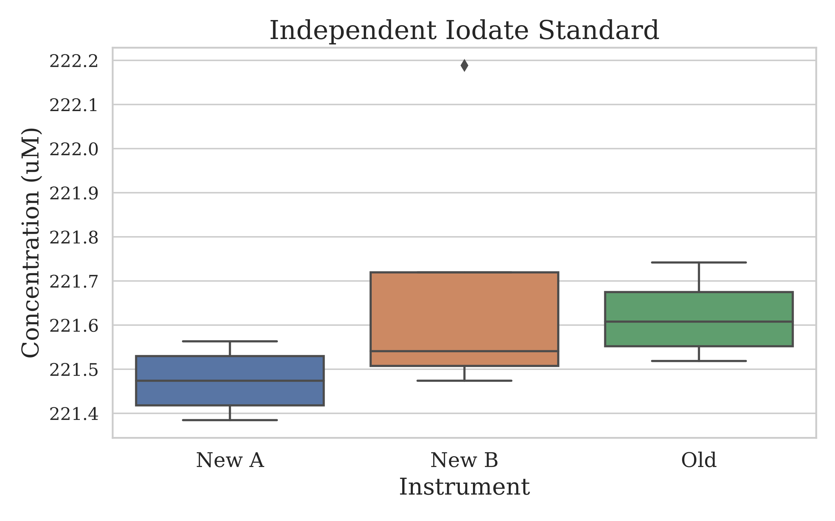

Figure 1.1.1: Boxplot style chart depicting the distribution of the independently dispensed Potassium Iodate standards measured by each instrument. Important to note that there was only 4 measurements made on each instruments.

### Iodate Standards Descriptive Statistics

|  |  |  |  |
| --- | --- | --- | --- |
|  | New A | New B | Old |
| Mean | 221.4739 | 221.6861 | 221.6191 |
| Median | 221.4739 | 221.5409 | 221.6079 |
| Standard Deviation | 0.0815 | 0.3369 | 0.0990 |
| % RSD | 0.037% | 0.152% | 0.045% |
| n | 4 | 4 | 4 |

Table 1.1.2: Basic descriptive statistics of the independently dispensed Potassium Iodate standards.

## Repeated Deep Sample Measurement: 1

Results section 3.2 pertains to the measurement of samples collected on deployment 1 from a depth of 1000 metres. Six sample replicates were taken from Niskins RP 3 to 7. For the first sub-section of this experiment, the 6 replicates from each Niskin were assigned to one instrument. For the second sub-section of this experiment, two replicates from each Niskin was measured by each instrument.



### Samples from One Niskin per Instrument

For each instrument tested, the samples were collected from a single Niskin. See table below for a tabulated view.

|  |  |  |  |
| --- | --- | --- | --- |
| Instrument | DEPLOYMENT | Niskin (RP) | Replicates |
| New A | 1 | 4 | 6 |
| New B | 1 | 7 | 6 |
| Old | 1 | 3 | 6 |

Table 1.2.1: Each instrument measured 6 replicate samples from a single niskin, the rosette position of the niskin is shown. Each bottle was fired sequentially, one after the other as quickly as possible at a depth of 1000 meters.

#### Samples from One Niskin Boxplot

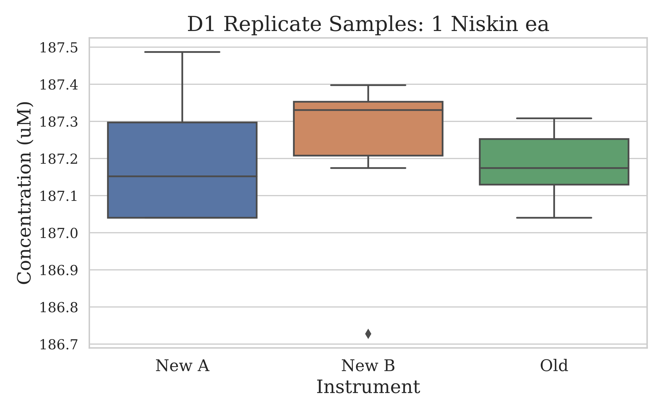

Figure 1.2.1.1: Boxplot style chart displaying the distribution of measurements for the sample replicates from each instrument.

#### Descriptive Statistics

|  |  |  |  |
| --- | --- | --- | --- |
|  | New A | New B | Old |
| Mean (uM) | 187.1966 | 187.2189 | 187.1817 |
| Median (uM) | 187.1520 | 187.3306 | 187.1743 |
| Standard Deviation | 0.1868 | 0.2526 | 0.0995 |
| % RSD | 0.100% | 0.135% | 0.053% |
| n | 6 | 6 | 6 |

Table 1.2.1.2: The basic descriptive statistics for the deep deployment sample replicates.

#### T-Test Comparison of Means

|  |  |  |
| --- | --- | --- |
| Comparison | P-Value | Significant Difference |
| New A to Old | 0.866 | No |
| New B to Old | 0.744 | No |

### Samples from Two Niskins for all Instruments

The samples to test all instruments were collected from two Niskins, this resulted in each instrument having 2 samples from each niskin – as 6 samples were collected from either Niskin.

#### Sample from Shared Niskins Boxplot

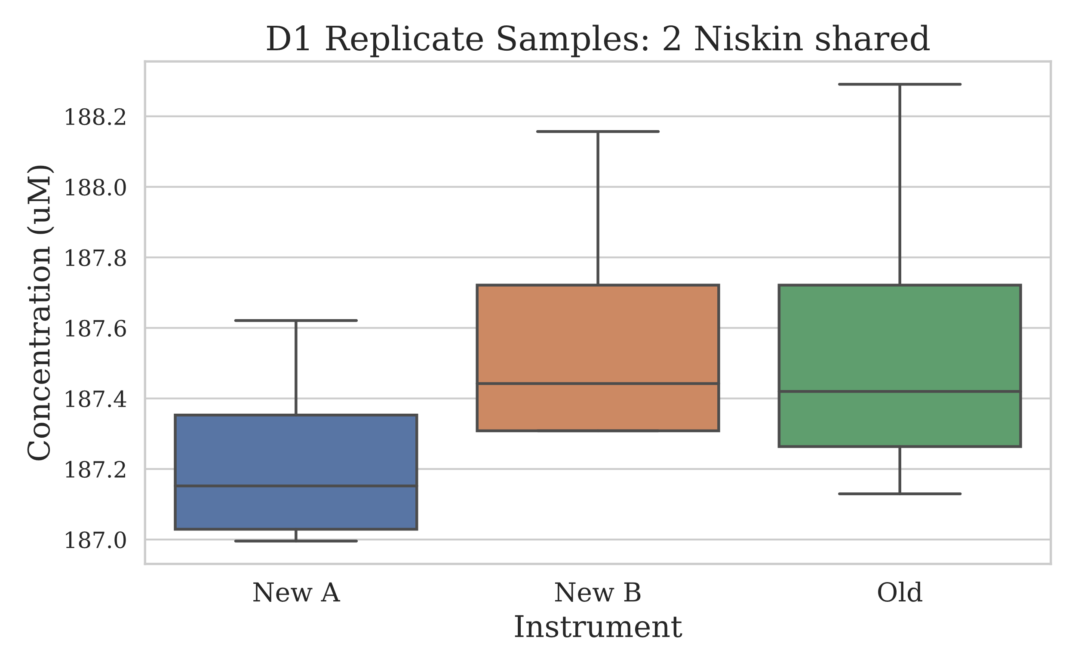

Figure 3.2.2.1: Depicted is a boxplot style chart where the samples measured are from 2 niskins and the replicates split between the 3 instruments. Each instrument made 4 measurements from the replicates pool.

#### Descriptive Statistics

|  |  |  |  |
| --- | --- | --- | --- |
|  | New A | New B | Old |
| Mean (uM) | 187.2301 | 187.5874 | 187.5650 |
| Median (uM) | 187.152 | 187.4422 | 187.4199 |
| Standard Deviation | 0.2856 | 0.4001 | 0.5110 |
| % RSD | 0.153% | 0.213% | 0.272% |
| n | 4 | 4 | 4 |

Table 3.2.2.2: Basic descriptive statistics of the shared deep water sample replicates.

## Atmospheric Saturated Sample: All Instruments

The results shown in this section, 3.3, were generated from the measurement of samples collected off the saturated oxygen rig. The rig was kept in the Hydrochemistry laboratory, where it equilibrated close to 21.5°C. Previous installation of the pressure monitor in the laboratory was used to get the air pressure at the time of sample collection. Both instances of sample collection, 12 samples were taken.

### Atmospheric Saturated Sample Boxplot (auto-scale)

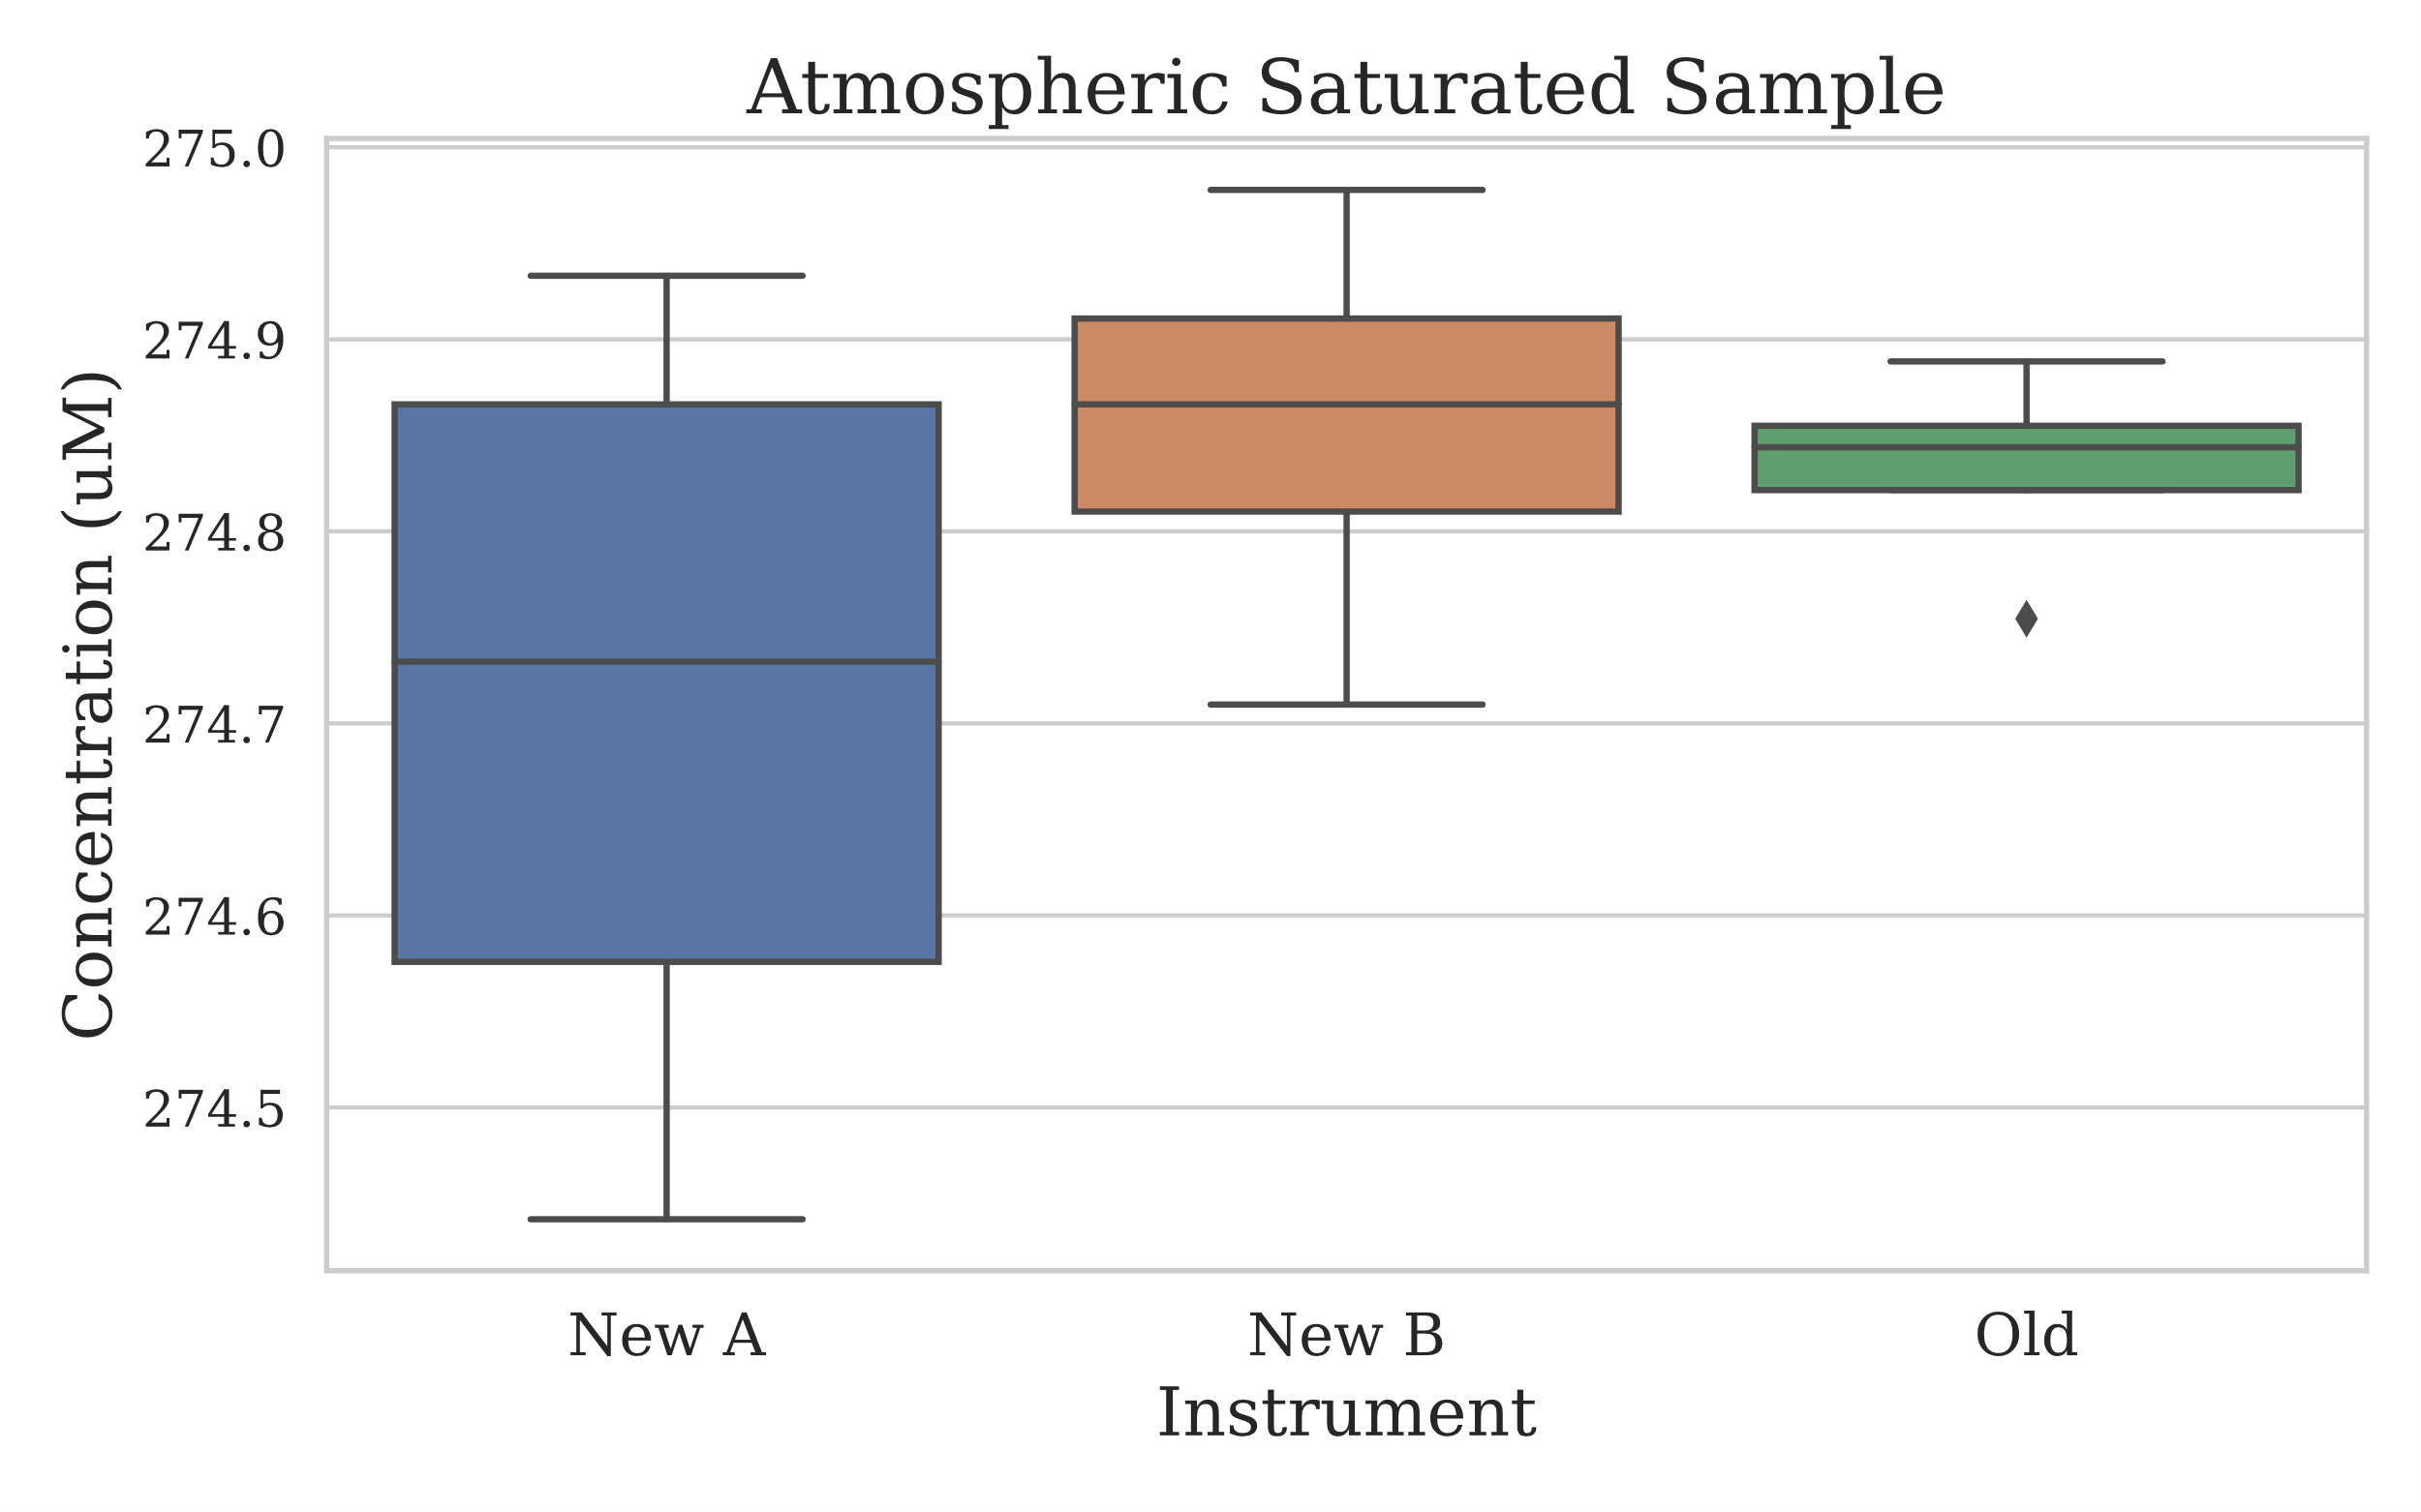

Figure 3.3.1: Boxplot style chart with the measurements made on the oxygen saturated samples created using the new rig. 12 samples in total were collected for this section, with each instrument analysing 4 of these.

### Atmospheric Saturated Sample Boxplot (QC Control Lines)

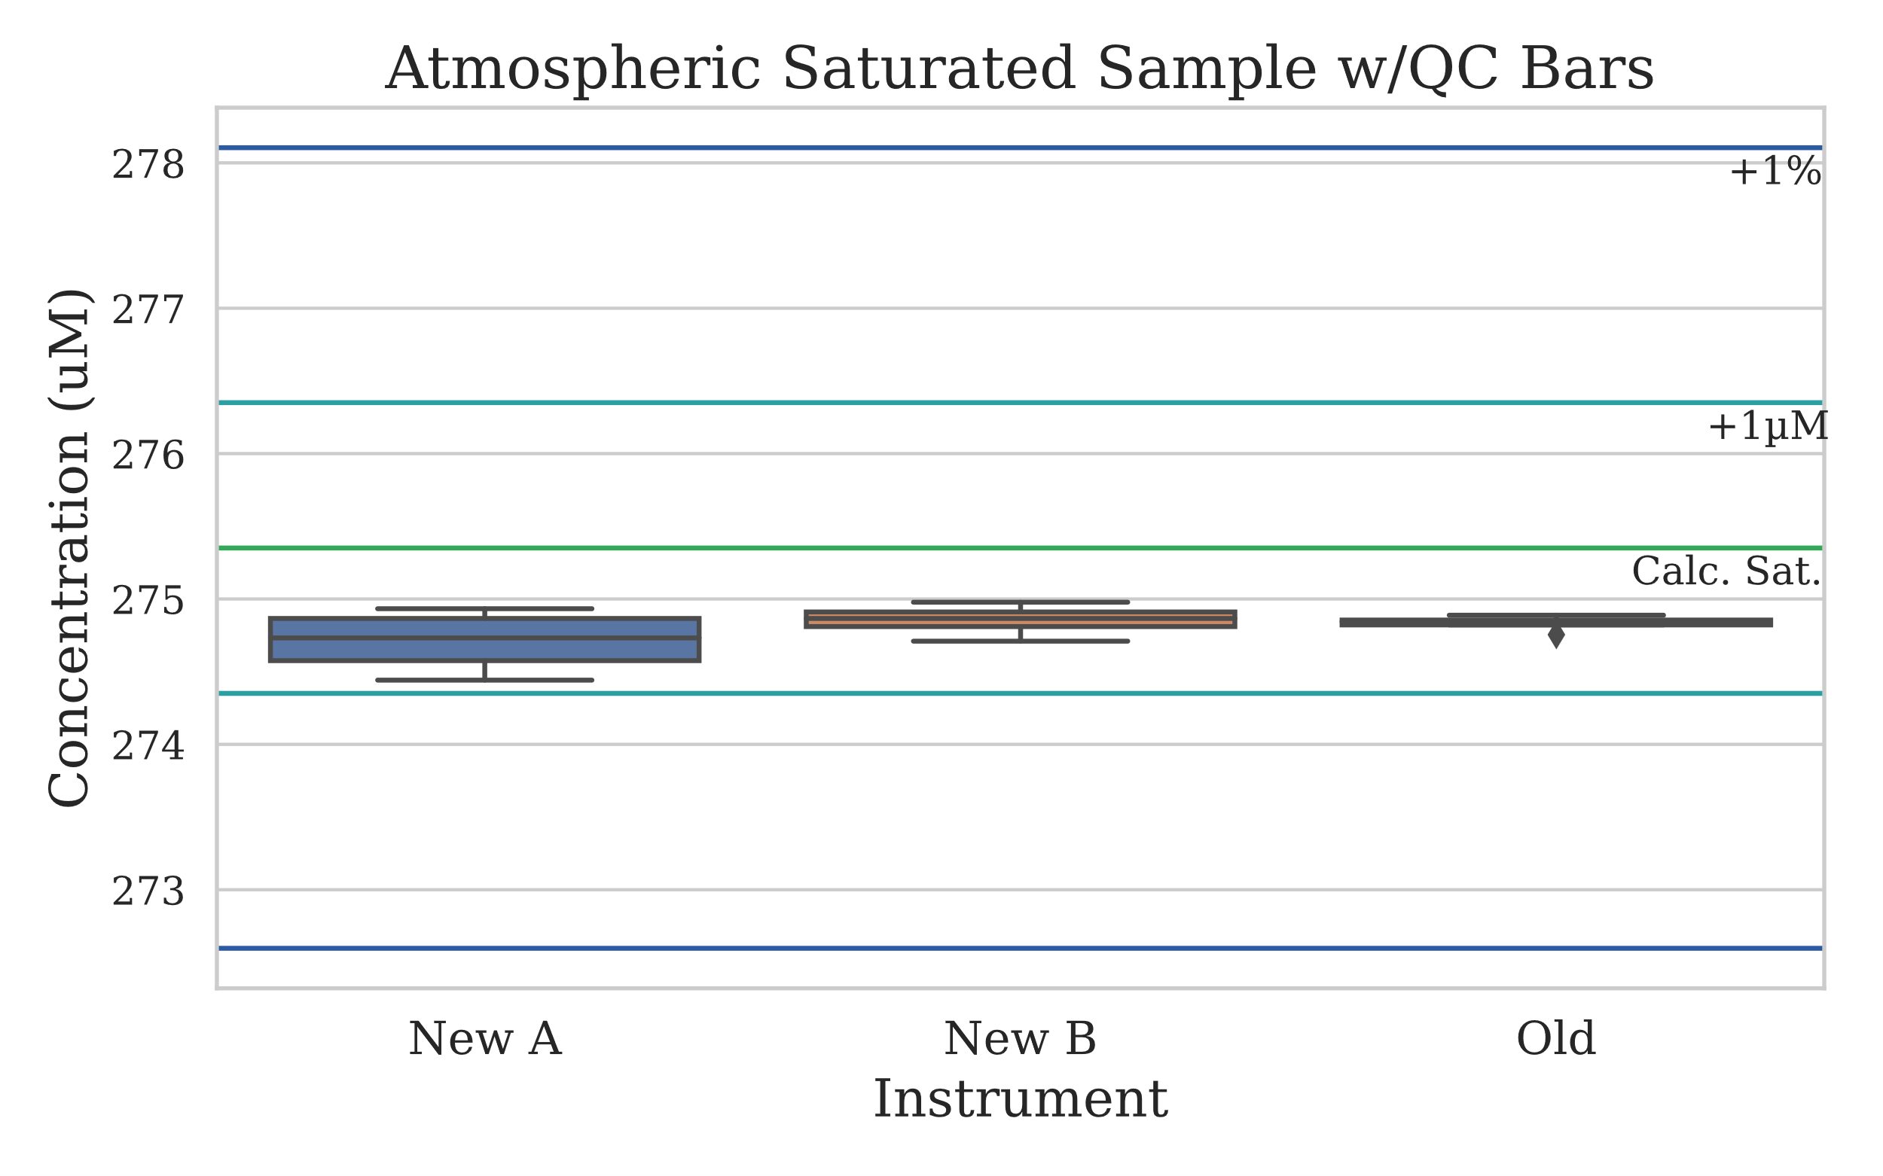

Figure 3.3.2: Boxplot of the same results from figure 3.3.1, however now depicted with quality control lines which show the theoretical oxygen saturation concentration (green), the saturated concentration ± 1µM (cyan) and the saturated concentration ± 1% of the concentration (blue).

### Descriptive Statistics

|  |  |  |  |
| --- | --- | --- | --- |
|  | New A | New B | Old |
| Mean (uM) | 274.7098 | 274.8550 | 274.8327 |
| Median (uM) | 274.7322 | 274.8662 | 274.8438 |
| Standard Deviation | 0.2218 | 0.1116 | 0.0562 |
| % RSD | 0.081% | 0.041% | 0.020% |
| n | 4 | 4 | 4 |

Table 3.3.3: Basic descriptive statistics of the saturated oxygen measurements.

## Atmospheric Saturated Sample: One Instrument

This section includes the results from the repeated measurement of saturated oxygen samples collected off of the rig. Samples were measured on instrument New B, this was 12 measurements.

### Atmospheric Saturated Sample: Instrument New B (auto-scale)

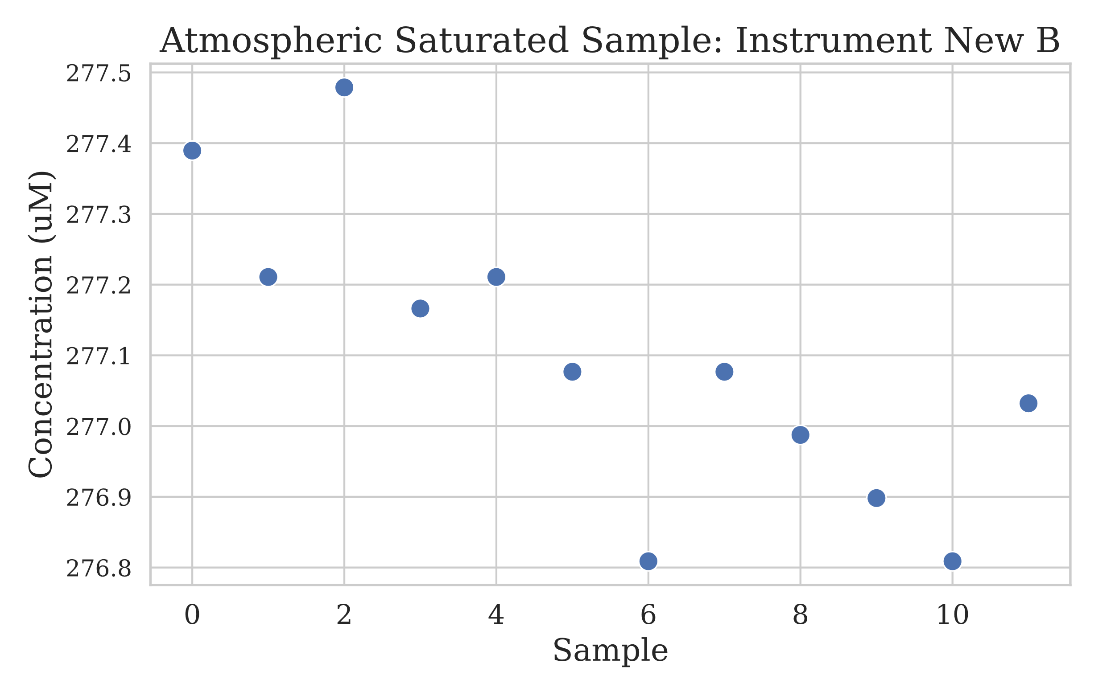

Figure 3.4.1: Scatter plot of the measurements made by instrument New B on a second set of 12 saturated oxygen atmospheric samples. The x axis is sample number in order of collection, y axis is concentration.

### Atmospheric Saturated Sample: Instrument New B (auto-scale)

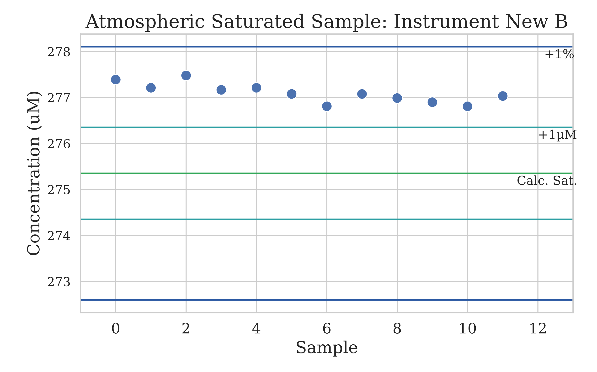

Figure 3.4.2: This scatter plot is like figure 3.4.1, however it includes quality control lines which show the theoretical oxygen saturation concentration (green), the saturated concentration ± 1µM (cyan) and the saturated concentration ± 1% of the concentration (blue).

### Atmospheric Saturated Sample: Instrument New B Boxplot (QC Control Limits)

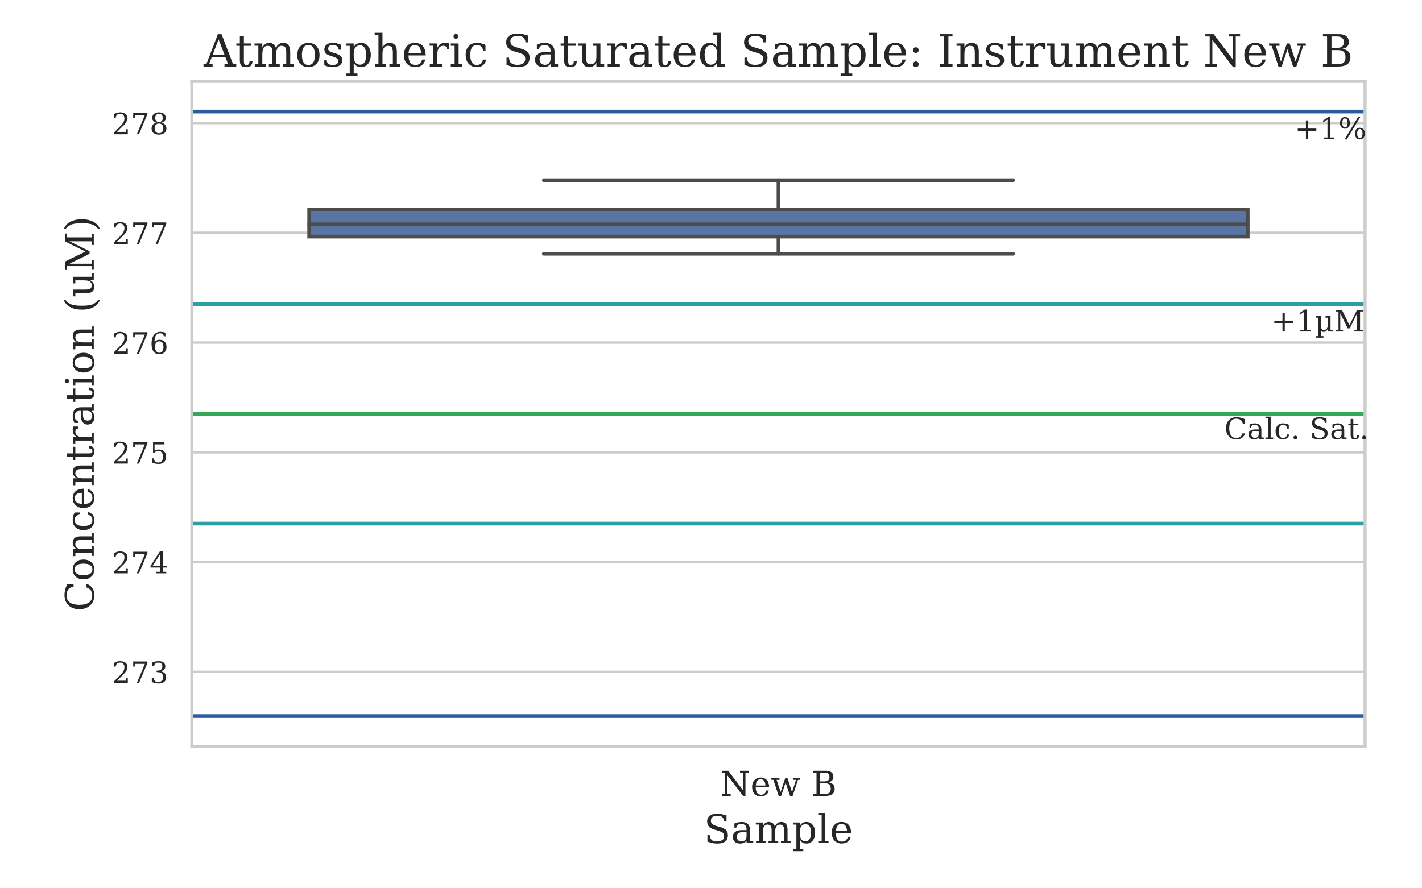

Figure 3.4.3: Very similar to figure 3.4.2, however depicted in a boxplot style to match the analysis completed on the other experiments.

## Water Profile Comparison

### Water Profile Plot

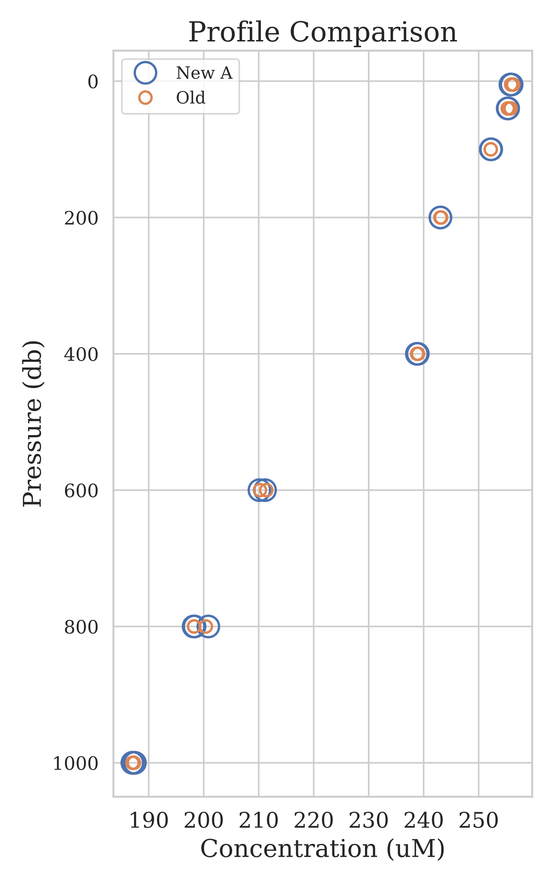



### T-Test Comparison of Means at specific depths

|  |  |  |
| --- | --- | --- |
| Depth | P-Value | Significant Difference |
| 5 | 0.10 | No |
| 40 | 0.30 | No |
| 800 | 0.90 | No |
| 1000 | 0.86 | No |

## Repeated Deep Sample Measurement: 2

### Deployment 2 Replicates Boxplot

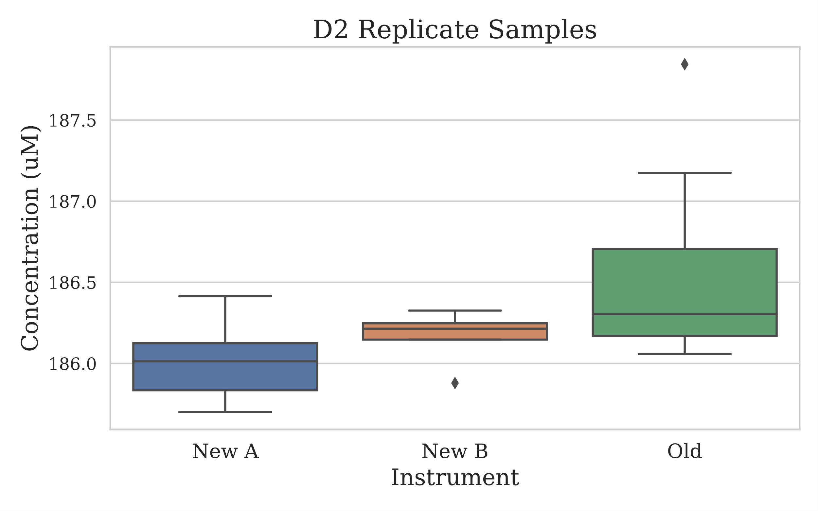

### T-Test Comparison of Means

|  |  |  |
| --- | --- | --- |
| Test Comparison | P-Value | Significant Difference |
| New A to Old | 0.04 | Yes |
| New B to Old | 0.11 | No |

# Discussion